xConnect System Support - xTP

**Revision History**

|  |  |  |  |
| --- | --- | --- | --- |
| Rev | Date | Author | Description |
| 1.0 | 10/22/2012 | Steve Groth | Release Version |
| 1.0 A | 10/23/2012 | Steve Groth | Added the following changes:   * Added warning information (Section 2) * Updated the Main Component diagram with a new one-directional arrow (Figure 5.2) * Updated the xTP Electronic Components diagram by taking out the software monitor reference and USB mini-B tab (Figure 5.4) * Updated the Component Data Sheet and Supply Chain sections with the color configuration part numbers for the xTPX (Dome) and with the part number for the xTPE (Sections 10,11) * Updated the introduction to the Troubleshooting section (section 12.1) * Various edits to ensure consistency in terminology for xTP, xTPX (Dome), xTPE |
| 1.0 B | 11/16/2012 | Steve Groth | Added the following changes:   * Added section on removing the DAP * Updated Component Data Sheet and Supply Chain sections * Updated the section on xTP/xBRC association * Added assembly drawing for the DAP head |
| 1.0 C | 1/09/2013 | Steve Groth | Added the following changes:   * Updated Component Data Sheet sections |
| 1.0 D | 4/01/2013 | Steve Groth | Added the following changes:   * Updated xTP/xBRMS association process |

**Document Approvers & Sign-Off**

|  |  |  |  |
| --- | --- | --- | --- |
| Date | Approver | Role | Document Accept/Reject |
| [Date] | [Insert Approver’s Name] | [Insert role] | [Accept/Reject] |

**Table of Contents**

[1 Introduction 4](#_Toc352769142)

[1.1 Definitions 4](#_Toc352769143)

[2 Safety Warnings 5](#_Toc352769144)

[2.1 Important Safety Instructions 5](#_Toc352769145)

[2.2 Explosive Safety Warning 6](#_Toc352769146)

[2.3 Lightning Warning 6](#_Toc352769147)

[2.4 Electrostatic Discharge Warning 6](#_Toc352769148)

[3 Installation Considerations 7](#_Toc352769149)

[3.1 Trained Installation and Service Personnel Warning 7](#_Toc352769150)

[4 System Function Description 8](#_Toc352769151)

[5 High-Level Drawings and Diagrams 8](#_Toc352769152)

[5.1 Top Level and Main Components Diagrams 9](#_Toc352769153)

[5.2 The Electronic Components 11](#_Toc352769154)

[5.3 The RFID Chain 12](#_Toc352769155)

[6 Description of Interfaces 14](#_Toc352769156)

[7 System Interconnect Diagram 15](#_Toc352769157)

[8 Communication System Diagrams 16](#_Toc352769158)

[9 Subsystem Assembly Drawings 17](#_Toc352769159)

[10 Component Data Sheets 18](#_Toc352769160)

[10.1 System Interconnect Diagram 18](#_Toc352769161)

[10.2 Component Data Sheet – xTP FP+ Assembly 18](#_Toc352769162)

[10.3 Component Data Sheet – xTP Assembly for Park Entry 21](#_Toc352769163)

[10.4 Component Data Sheet – xTPra (Remote Antenna) 24](#_Toc352769164)

[10.5 Component Data Sheet – xTPrs (Remote Sensor) 26](#_Toc352769165)

[11 Supply Chain Information 27](#_Toc352769166)

[11.1 xTP for FP+ Supply Chain Information 28](#_Toc352769167)

[11.2 xTP for Park Entry Supply Chain Information 30](#_Toc352769168)

[11.3 xTPra Supply Chain Information 31](#_Toc352769169)

[11.4 xTPrs Supply Chain Information 33](#_Toc352769170)

[12 Troubleshooting Guide 33](#_Toc352769171)

[12.1 Removing and replacing the xTP and DAP 33](#_Toc352769172)

[12.2 Performing the xTP Association in xBRMS 48](#_Toc352769173)

[12.2.1 Replacing an xTP in xBRMS 48](#_Toc352769174)

[12.3 Identifying and assigning unassigned readers 58](#_Toc352769175)

[12.3.1 Assigning a reader to the correct xBRC 59](#_Toc352769176)

[12.4 If the reader does not show in xBRMS 66](#_Toc352769177)

[12.5 Testing the xTP 67](#_Toc352769178)

[12.6 Troubleshooting problems with the xTP 68](#_Toc352769179)

[13 Obsolete Equipment 69](#_Toc352769180)

# Introduction

This document provides a description of the high-level design for the xTP. This includes:

* A list of definitions for the terms used in this document
* A high-level functional description of the purpose of the xTP
* A series of drawings and diagrams showing the main components of the xTP
* A description of interfaces that describes how the xTP is used
* A system interconnect diagram that shows the cabling between electronic components
* A series of drawings showing the assembly of the xTP
* A component data sheet table listing the physical, environmental, electrical, and regulatory features of the xTP
* Supply chain information
* Detailed information about how to diagnose and troubleshoot any problems you may encounter when installing and using the xTP
* Information about the handling of obsolete equipment

## Definitions

For this document, the following acronyms are used:

|  |  |
| --- | --- |
| **Term** | **Definition** |
| DAP | Disney Access Portal, an xTP configured with a biometric reader for use at Park Entry locations |
| ESB | Enterprise Service Bus |
| GxP | Code that handles entitlements |
| HTTP | Hypertext Transfer Protocol |
| IDMS | Code and database storing Guest and MagicBand information |
| JSON | JavaScript Object Notation |
| JMS | Java Message Service |
| MagicBand | RFID device worn by Guests |
| REST | Representational State Transfer |
| RFID | Radio-frequency identification |
| xBR | Long range RFID reader with uni- or omni-directional antennae |
| xBRC | Code package that manages xBRs, xTPs, and DAP devices |
| xBRMS | Database that stores operational data |
| xConnect | Code, scripts, APIs, and database schemas that comprise the unifying messaging, management, and reporting software that ties the hardware together into a coherent solution |
| xi | Experience Intelligence |
| XML | Extensible Markup Language |
| xTP | Experience Touch Point, a Disney-themed short range RFID reader or “touch” device. Note that in other documents “xTP” is used to describe the entire unit; however, in this document it is a component piece of the overall assembly. |
| xTPra | Remote access touch point |
| xTPrs | Remote sensor touch point |

# Safety Warnings

## Important Safety Instructions

When using this device, follow these safety precautions to reduce the risk of fire, electric shock and injury to persons.

## Explosive Safety Warning

**Warning** Do not operate this device near explosive devices, unshielded blasting caps or in an otherwise explosive environment unless the device has been approved for such use by qualified personnel.

**Warning** Do not disconnect the power or any other cabling in an explosive environment until such qualified personnel, trained specifically in explosive environment handling, have determined it is safe to do so.

## Lightning Warning

Avoid using this product during an electrical storm. There may be a remote risk of electric shock from lightning.

## Electrostatic Discharge Warning

**Warning** Wear an anti-static wrist strap or take other suitable measures to prevent electrostatic discharge when handling this equipment.

# Installation Considerations

## Trained Installation and Service Personnel Warning

**Note** Installation and service of this product is to be performed by trained installation and service personnel only. Read and follow all warning notices and instructions marked on the product or included in the documentation. Before installing the product, read the rest of this document and follow specific product instructions.

When installing, the placement of the device must also satisfy the following installation requirements:

* Placement must allow for easily disconnecting the power cord/adapter of the device from the AC wall-outlet.
* Keep the device away from excessive heat and humidity and keep the device free from vibration and dust.
* Installation must at all times conform to local regulations.
* Network Connections can be made with either Unshielded Twisted Pair (UTP) or Shielded Twisted Pair (STP) cabling.

# System Function Description

The xTP is a second generation Experience Touch Point. The primary function of the xTP is to read RFID tags (embedded either in cards or in a wrist worn MagicBand) and to relay that information from these tags to the xBRC system using an Ethernet connection. When the xTP is used for Park Entry it is referred to as a Disney Access Portal (DAP) and when it is used at different locations in the park, it is referred to as a Touch Point (xTP). The xTP also includes a high brightness RGB LED display, sound for user feedback, and a USB port to connect to a biometric (fingerprint) reader.

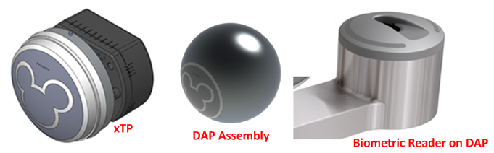

Figure 4.1: xTP, DAP, and Biometric Reader

# High-Level Drawings and Diagrams

The following diagrams and drawings provide different perspectives of the xTP and its role in the xConnect system. This includes:

* A top level block diagram that shows how the xTP fits into the xConnect System
* A diagram that shows the main components of the xTP and its internal and external connections
* The electronic components of the xTP
* The RFID components of the xTP

## Top Level and Main Components Diagrams

Figure 5.1 shows how the xTP fits into the xConnect System.

**Note** See section 1.1 for a list of acronyms used in this document.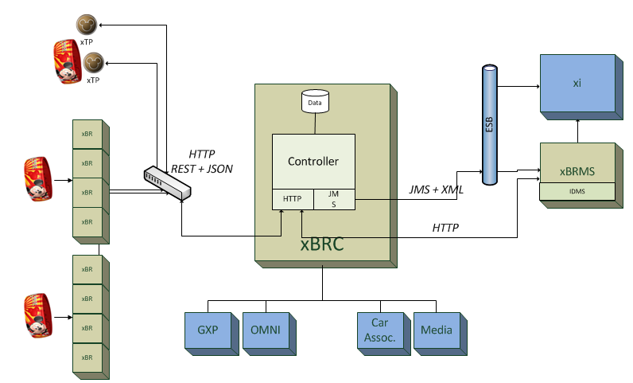

Figure 5.1: xTP High Level Overview

Figure 5.2 shows the main components of the xTP and its internal and external connections.

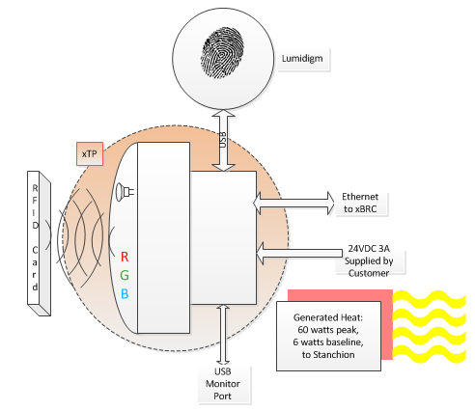

Figure 5.2: xTP Main Components Diagram

## The Electronic Components

Figure 5.3 shows the two main components of the xTP: the xTPX (Dome), xTPE, and the two together as an assembled xTP.

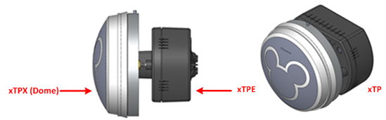

Figure 5.3: xTPX (Dome), xTPE, and xTP

Figure 5.4 shows the main electronic components of the xTP.

Shown in green, there are four printed circuit boards that make up the xTP electronics. The functions and interconnections of these printed circuit boards are shown below.

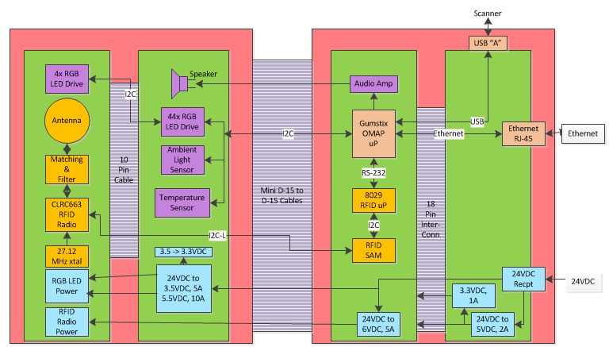

Figure 5.4: xTP Electronic Components

## The RFID Chain

Figure 5.5 shows the RFID components of the xTP. The RFID chain is based on the following parts:

* A TDA8029HL reader control IC (Integrated Circuit)
* A P5DF081HN\_T1AR1070 RFID Secure Access Module (SAM)
* A CLRC66301HN,551 reader radio transceiver (XCVR) IC

The XCVR IC is followed by an analog matching and filtering circuit that optimally connects the XCVR to the antenna coil.

The reader control IC is a preprogrammed microprocessor used to decode and implement high-level commands sent from a host computer via (Universal Asynchronous Receiver/Transmitter) UART. The host in this case is the Gumstix card.

To unburden the system of time consuming tasks, the integrated SAM chip decodes commands from the reader chip, such as verification of a secure link between the reader and an external tag. Allowing the SAM chip to perform these tasks locally speeds up RFID transactions because communication between the host and the XCVR is minimized.

The SAM chip also communicates with the XCVR IC using a modified I2C communications methodology called I2C-L. This short range, point to point serial protocol runs at about 2.5Mbaud. No pullups are required on either the clock or on data lines.

The XCVR’s analog interface is made up of a differential output, a differential input, and a bias voltage.

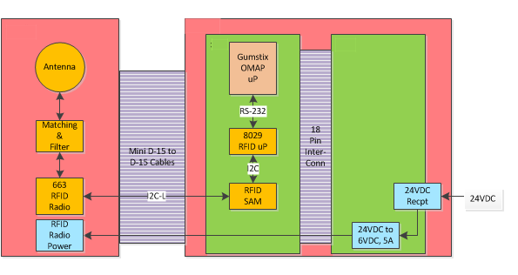 Figure 5.5: RFID Signal Flow Diagram

# Description of Interfaces

When used for Park Entry, the xTP has a biometric reader attached and is referred to as the DAP. The xTP can be configured for Park Entry, FastPass+ Queues or other areas like the Great Food Fast (GFF) restaurant program. The xTP will detect a FastPass + test card or MagicBand within close proximity in order to read ID information.

An xTP is associated with one xBRC. The xBRC assists in determining entitlement status for a guest by placing JMS messages on the ESB (Enterprise Service Bus) which are then consumed by other downstream applications (xBMS, GxP, xi, etc.). The following list outlines how the xTP is used.

Park Entry:

* When a Guest enters the park, they are required to touch the DAP with a FastPass + test card /MagicBand and provide a fingerprint in the biometric reader.
* The DAP sends events to the xBRC which will then determine the status of the Guest via integration with the ticketing system.
* The xBRC tells the DAP to light up with appropriate colors, sequences and sounds. A green light indicates successful entry and a blue light indicates there was an issue with the Guest’s pass.

FastPass+:

* When used at an attraction, the FastPass + test card/MagicBand is used for entry into the FastPass+ queue. The queue has an entry point and a merge point. The standby queue meets with the FastPass+ queue at the merge point.

Great Food Fast:

* The xTP is used to identify when guests have arrived at the entrance to the restaurant.

Immersive Experiences (WDI):

* The xTP will be used to identify guests in conjunction with a set of unique individualized experiences.

# System Interconnect Diagram

Figure 7.1 shows the cabling between electronic components and how these units are connected.

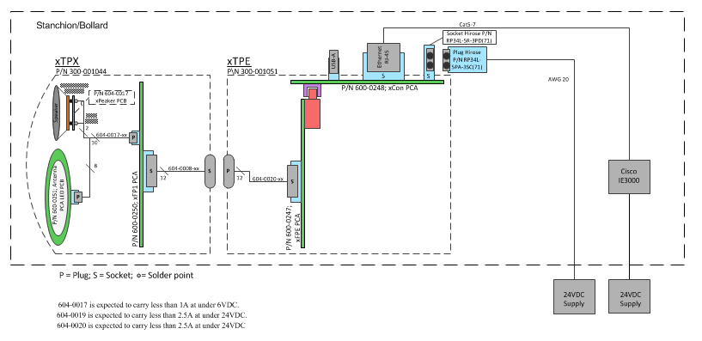

Figure 7.1: System Interconnect Diagram

# Communication System Diagrams

For more information about the communication system and how the xTP interacts with the xBRC, see the document 900-0103 Rev 1.0 xConnect System Support-xBRC.

# Subsystem Assembly Drawings

This section contains xTP assembly drawings and information about the xTP components.

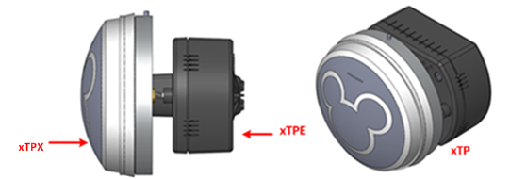

Figure 9.1: xTP Main Components

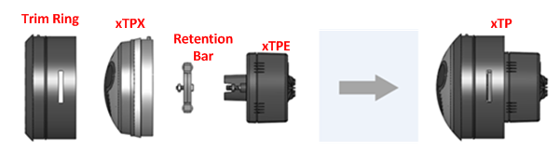

Figure 9.2: xTP Assembly

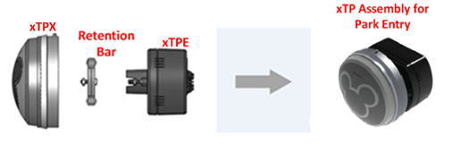

Figure 9.3: xTP Assembly for Park Entry

# Component Data Sheets

This section provides data sheets that provide a list of features and part numbers for the xTP for FP +, FTP for Park Entry, and for the xTPra and xTPrs.

## System Interconnect Diagram

See section 7, Figure 7.1 for the System Interconnect Diagram.

## Component Data Sheet – xTP FP+ Assembly

This section provides a list of features for the xTP Assembly for FastPass Plus (FP+) and for its component part numbers.

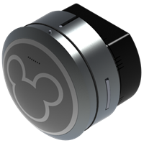

Figure 10.1: xTP for FP + Assembly

The following table provides the performance and other technical features of the xTP for FP +.

|  |  |
| --- | --- |
| **Component** | **Features and Part Numbers** |
| **xTP FP+ Assembly** | Notes:   * The xTP FP+ Assembly is currently offered in four color combinations. * Part numbers are assigned based on different color combinations for the dome and the trim ring. * The numbering convention used is: 300-001449-XXXX, where the dome color is indicated by the first two XXs and the trim ring by the second two XXs. |
| Part Numbers | The xTP FP+ Assembly is available with the following part numbers:   * **300-001449-0102**   CWCL 3164M/Light Gray dome with “clear” aluminum trim ring.   * **300-001449-0205**   DuPont Spectramaster YS146/Dark Brown dome with light bronze trim ring.   * **300-001449-0304**   DuPont Spectramaster DS171/Dark Gray dome with black trim ring.   * **300-001449-0403**   Pantone 464U/Light Brown dome with gold trim ring. |
| General | * Indicators   + Ethernet indicator lights   + Power indicator light, 24v LED   + Animated RGB backlit Mickey Icon and outer ring |
| Physical | * Material, xTP: polycarbonate * Unit Weight, xTP: 314 grams (0.69 lbs.) |
| Environmental | * Operating Temperature: -10◦ C to 50◦ C * Operating Humidity: 90% condensing cycle * Environmental Sealing: IP56 |
| Electrical | * Operating Frequency:   + RFID: 13.56 MHz ISO-14443A band * Rated Operation Voltage: 24 volts +/- 20% * Current Consumption: 3 amps maximum * Operating Distance   + MagicBand: Greater than 3 mm   + RFID card: Greater than 5 mm |
| Regulatory Compliance | * Vision Safety: CIE/IEC 62471 * Safety: UL 60950-1 * EMC: FCC Part 15, Class K |
| **xTPX (Dome) Subassembly** | The xTPX (Dome) Subassembly is available with the following part numbers:   * **300-001044-01**   CWCL 3164M/Light Gray   * **300-001044-02**   DuPont Spectramaster YS146/Dark Brown   * **300-001044-03**   DuPont Spectramaster DS171/Dark Gray   * **300-001044-04**   Pantone 464U/Light Brown |
| **xTPE Enabler** | Part Number:   * **300-001051** |
| **Trim Ring** | The trim ring for the xTP Assembly is available with the following part numbers:   * **300-001140-02**    “Clear” Aluminum Trim Ring * **300-001140-03**    Gold Trim Ring * **300-001140-04**    Matte Black Trim Ring * **300-001140-05**    Light Bronze Trim Ring |
| **Retention Bar** | Part Number:   * **300-001200** |

## Component Data Sheet – xTP Assembly for Park Entry

This section provides a list of features for the xTP Assembly for Park Entry (PE) and its component part numbers. The xTP Assembly for PE is identical to the xTP Assembly for FP+ except that it does not include a Trim Ring.

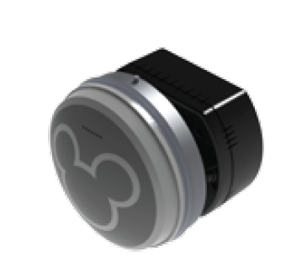

Figure 10.2: xTP for Park Entry Assembly

|  |  |
| --- | --- |
| **Component** | **Features and Part Numbers** |
| **xTP Assembly for PE** | Notes:   * The xTP Assembly for Park Entry is currently offered in four color combinations. * Part numbers are assigned based on different color combinations for the dome. * The numbering convention used is: 300-001536-XX, where the dome color is indicated by the XXs. |
| Part Numbers | The xTP Assembly for PE is available with the following part numbers:   * **300-001536-01**   CWCL 3164M/Light Gray dome   * **300-001536-02**   DuPont Spectramaster YS146/Dark Brown dome   * **300-001536-03**   DuPont Spectramaster DS171/Dark Gray dome   * **300-001536-04**   Pantone 464U/Light Brown |
| General | * Indicators   + Ethernet indicator lights   + Power indicator light, 24v LED   + Animated RGB backlit Mickey Icon and outer ring |
| Physical | * Material, xTP: polycarbonate * Unit Weight, xTP: 314 grams (0.69 lbs.) |
| Environmental | * Operating Temperature: -10◦ C to 50◦ C * Operating Humidity: 90% condensing cycle * Environmental Sealing: IP56 |
| Electrical | * Operating Frequency:   + RFID: 13.56 MHz ISO-14443A band * Rated Operation Voltage: 24 volts +/- 20% * Current Consumption: 3 amps maximum * Operating Distance   + MagicBand: Greater than 3 mm   + RFID card: Greater than 5 mm |
| Regulatory Compliance | * Vision Safety: CIE/IEC 62471 * Safety: UL 60950-1 * EMC: FCC Part 15, Class K |
| **xTPX (Dome) Subassembly** | The xTPX (Dome) Subassembly is available with the following part numbers:   * **300-001044-01**   CWCL 3164M/Light Gray   * **300-001044-02**   DuPont Spectramaster YS146/Dark Brown   * **300-001044-03**   DuPont Spectramaster DS171/Dark Gray   * **300-001044-04**   Pantone 464U/Light Brown |
| **xTPE Enabler** | Part Number:   * **300-001051** |
| **Retention Bar** | Part Number:   * **300-001200** |

## Component Data Sheet – xTPra (Remote Antenna)

This section provides a part number as well as a list of technical features for the xTPra.

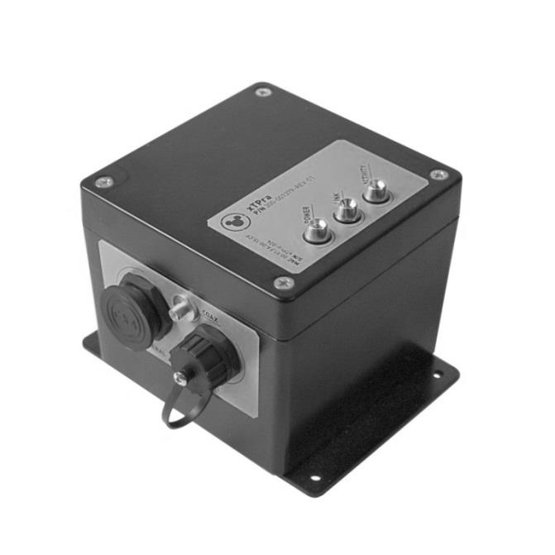

Figure 10.3: xTPra

The following table provides the performance and other technical features of the xTPra.

|  |  |
| --- | --- |
| **Component: xTPra** | **Features and Part Numbers** |
| Part Number | * **300-001379-01** |
| General | * Indicators: Ethernet indicator light and power indicator light |
| Physical | * Material: Aluminum * Dimensions   + Height: 4.090”   + Width: 4.75”   + Length: 5.874” (including mounting plate) * Unit Weight: 2.6 lb. |
| Environmental | * Temperature   + Operating: -10°C to 50°C   + Storage: -20°C to 60°C * Operating Relative Humidity: 90% condensing/non-condensing * Altitude: 8,000 ft. @28°C (82.4°F) |
| Electrical | * Power   + The xTPra’s power source is via the PoE capable Ethernet port. * RFID Capabilities   + TX/RX: 13.56 MHz   + ISO 14443A, with support for proprietary security protocols * Rated operating voltage: Minimum 1A * Power consumption: 6 watts maximum * Operating distance: Operating distance is installation and antenna dependent |
| Regulatory Compliance | * Safety: The xTPra has been certified as a UL Listed Product to the UL 60950-1 standard. * This device complies with part 15 of the FCC Rules. |

## Component Data Sheet – xTPrs (Remote Sensor)

This section provides a part number as well as a list of technical features for the xTPrs.



Figure 10.4: xTPrs

The following table provides the performance and other technical features of the xTPrs.

|  |  |
| --- | --- |
| **Component: xTPrs** | **Features and Part Numbers** |
| Part Number | * **300-001379-02** |
| General | * Indicators: Ethernet indicator light and Power indicator light |
| Physical | * Material: Aluminum * Dimensions   + Height: 4.090”   + Width: 4.75”   + Length: 5.874” (including mounting plate) * Unit Weight: 2.6 lb. |
| Environmental | * Temperature   + Operating: -10°C to 50°C   + Storage: -20°C to 60°C * Operating Relative Humidity: 90% condensing/non-condensing * Altitude: 8,000 ft. @28°C (82.4°F) |
| Electrical | * Power   + DC power is provided through the peripheral connector interface.     - DC Input: 24Vdc, 1A max     - Note: This product must be used with a DC power source that is cULus (NRTL) Listed, with an output rated 24VDC +/- 20% maximum, minimum 1A , Marked “LPS” or “Class 2”, output rated SELV, non-energy hazardous and suitable for connection to a standard power receptacle in the US and Canada. * RFID Capabilities   + TX/RX: 13.56 MHz   + ISO 14443A, with support for proprietary security protocols * Rated operation voltage: Minimum 1A * Power consumption: 6 watts maximum * Operating distance: Operating distance is installation and antenna dependent |
| Regulatory Compliance | * Safety: The xTPrs has been certified as a UL Recognized Component to the 60950-1 Standard. * This device complies with part 15 of the FCC Rules. |

# Supply Chain Information

The tables in this section show the part numbers for the xTP and xTPra components. To order replacement components please call 1-866-534-7639, and request that an incident be opened to assignment group, app-flwdw-ngexcon.

## xTP for FP+ Supply Chain Information

The following table provides the information and part numbers required to order replacement parts for xTP for FP+.

|  |  |
| --- | --- |
| **Component** | **Features and Part Numbers** |
| **xTP Assembly for FP+** | Notes:   * The xTP Assembly for FP+ is currently offered in four color combinations. * Part numbers are assigned based on different color combinations for the dome and the trim ring. * The numbering convention used is: 300-001449-XXXX, where the dome color is indicated by the first two XXs and the trim ring by the second two XXs. |
| Part Numbers | The xTP Assembly for FP+ is available with the following part numbers:   * **300-001449-0102**   CWCL 3164M/Light Gray dome with “clear” aluminum trim ring.   * **300-001449-0205**   DuPont Spectramaster YS146/Dark Brown dome with light bronze trim ring.   * **300-001449-0304**   DuPont Spectramaster DS171/Dark Gray dome with black trim ring.   * **300-001449-0403**   Pantone 464U/Light Brown dome with gold trim ring. |
| **xTPX (Dome) Subassembly** | The xTPX (Dome) subassembly is available with the following part numbers:   * **300-001044-01**   CWCL 3164M/Light Gray   * **300-001044-02**   DuPont Spectramaster YS146/Dark Brown   * **300-001044-03**   DuPont Spectramaster DS171/Dark Gray   * **300-001044-04**   Pantone 464U/Light Brown |
| **xTPE Enabler** | Part Number:   * **300-001051** |
| **Trim Ring** | The trim ring for the xTP Assembly is available with the following part numbers:   * **300-001140-02**    “Clear” Aluminum Trim Ring * **300-001140-03**    Gold Trim Ring * **300-001140-04**    Matte Black Trim Ring * **300-001140-05**    Light Bronze Trim Ring |
| **Retention Bar** | Part Number:   * **300-001200** |
| Physical | * Material, xTP: polycarbonate * Unit Weight, xTP: 314 grams (0.69 lbs.) |

## xTP for Park Entry Supply Chain Information

The following table provides the information and part numbers required to order replacement parts for xTP for Park Entry (PE).

|  |  |
| --- | --- |
| **Component** | **Features and Part Numbers** |
| **xTP Assembly for Park Entry** | Notes:   * The xTP Assembly for PE is currently offered in four color combinations. * Part numbers are assigned based on different color combinations for the dome. * The numbering convention used is: 300-001536-XX, where the dome color is indicated by the XXs. |
| Part Numbers | The xTP Assembly for PE is available with the following part numbers:   * **300-001536-01**   CWCL 3164M/Light Gray dome   * **300-001536-02**   DuPont Spectramaster YS146/Dark Brown dome   * **300-001536-03**   DuPont Spectramaster DS171/Dark Gray dome   * **300-001536-04**   Pantone 464U/Light Brown dome |
| **xTPX (Dome) Subassembly** | The xTPX (Dome) subassembly is available with the following part numbers:   * **300-001044-01**   CWCL 3164M/Light Gray   * **300-001044-02**   DuPont Spectramaster YS146/Dark Brown   * **300-001044-03**   DuPont Spectramaster DS171/Dark Gray   * **300-001044-04**   Pantone 464U/Light Brown |
| **xTPE Enabler** | Part Number:   * **300-001051** |
| **Retention Bar** | Part Number:   * **300-001200** |
| Physical | * Material, xTP: polycarbonate * Unit Weight, xTP: 314 grams (0.69 lbs.) |

## xTPra Supply Chain Information

The following table provides the information and part numbers required to order replacement parts for xTPra.

|  |  |
| --- | --- |
| **Component: xTPra** | **Features and Part Numbers** |
| Part Number | * **300-001379-01** |
| Physical | * Material: Aluminum * Dimensions   + Height: 4.090”   + Width: 4.75”   + Length: 5.874” (including mounting plate) * Unit Weight: 2.6 lb. |

## xTPrs Supply Chain Information

The following table provides the information and part numbers required to order replacement parts for xTPrs.

|  |  |
| --- | --- |
| **Component: xTPrs** | **Features and Part Numbers** |
| Part Number | * **300-001379-02** |
| Physical | * Material: Aluminum * Dimensions   + Height: 4.090”   + Width: 4.75”   + Length: 5.874” (including mounting plate) * Unit Weight: 2.6 lb. |

# Troubleshooting Guide

The following section is designed to help troubleshoot any potential problems with the xTP. This includes:

* The steps for removing and replacing the xTP and park entry DAP.
* The steps required for xTP bring-up. Specifically, associating the xTP with the xBRC.
* Touch tests following replacement to ensure the xTP is functioning correctly.
* A list of potential problems and how to resolve or escalate each problem.

## Removing and replacing the xTP and DAP

The following section provides step by step instructions for removing and replacing the xTP and the park entry DAP.

**Removing and replacing the xTP**

The xTP was designed to be installed in various stanchion/enclosure designs.

The images below show the xTP being installed into a stanchion mock up showing the front face and back wall to demonstrate the steps involved with installation. An actual stanchion is a full enclosed, sealed enclosure for the xTP.

**xTP Swap Out Procedure:**

To remove the xTP:

1. Using a 3/16th hex key, turn the screw at the back of the stanchion counter clockwise.

|  |  |
| --- | --- |
| S:\projects\Disney\Scooter\Photos and Video\2012-08-21 FOS Swap Out Procedure\JPG\Thumbnails for Manual\xTP Stanchion-1\IMG_3776.jpg | S:\projects\Disney\Scooter\Photos and Video\2012-08-21 FOS Swap Out Procedure\JPG\Thumbnails for Manual\xTP Stanchion-1\IMG_3779.jpg |

Figure 12.1 – Turning the Hex Screw

1. Continue to turn the screw while gently pulling the xTP until it releases from the screw.

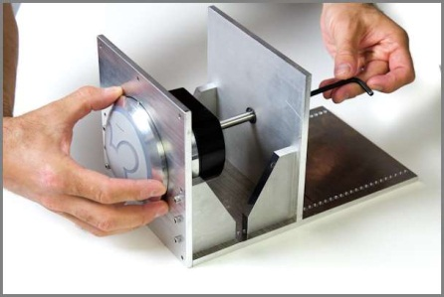

Figure 12.2 – Gently Pull the xTP from the Stanchion

1. Pull the xTP free of the stanchion taking care to not strain the Ethernet or power leads.

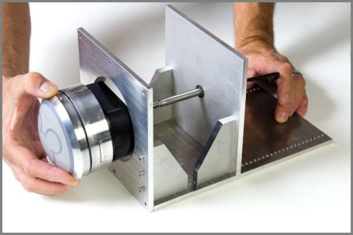

Figure 12.3 – Pulling the xTP Free

1. Unplug the Ethernet and power leads, leaving them hanging outside the stanchion opening, taking care not to let the leads fall back into the stanchion.

|  |  |
| --- | --- |
| S:\projects\Disney\Scooter\Photos and Video\2012-08-21 FOS Swap Out Procedure\JPG\Thumbnails for Manual\xTP Stanchion-1\IMG_3790-Edit.jpg | S:\projects\Disney\Scooter\Photos and Video\2012-08-21 FOS Swap Out Procedure\JPG\Thumbnails for Manual\xTP Stanchion-1\IMG_3795-Edit.jpg |

Figure 12.4 – Unplugging the Ethernet and Power Leads

To replace the xTP:

1. Ensure that the O-ring is lubricated with Molykote 55 (provided by Engineering Services).

|  |  |
| --- | --- |
| S:\projects\Disney\Scooter\Photos and Video\2012-08-21 FOS Swap Out Procedure\JPG\Thumbnails for Manual\xTP Stanchion-1\IMG_3797.jpg |  |

Figure 12.5 – Lubricating the O-ring

1. Plug in the Ethernet and power leads into the ports at the back of the xTP.

|  |  |
| --- | --- |
| S:\projects\Disney\Scooter\Photos and Video\2012-08-21 FOS Swap Out Procedure\JPG\Thumbnails for Manual\xTP Stanchion-1\IMG_3804.jpg | S:\projects\Disney\Scooter\Photos and Video\2012-08-21 FOS Swap Out Procedure\JPG\Thumbnails for Manual\xTP Stanchion-1\IMG_3801.jpg |

Figure 12.6 – Plugging in the Ethernet and Power Leads

1. Wait for the Ethernet indicator lights to show connection and activity by blinking. Note that the blinking light should occur within a few seconds, but it may take up to two minutes.

|  |  |
| --- | --- |
| S:\projects\Disney\Scooter\Photos and Video\2012-08-21 FOS Swap Out Procedure\JPG\Thumbnails for Manual\xTP Stanchion-1\IMG_3807.jpg | S:\projects\Disney\Scooter\Photos and Video\2012-08-21 FOS Swap Out Procedure\JPG\Thumbnails for Manual\xTP Stanchion-1\IMG_3807-Edit.jpg |

Figure 12.7 – Ethernet Indicator Lights

1. Orient the xTP Trim Ring pin to the groove in the stanchion (12 o’clock).

|  |  |
| --- | --- |
| S:\projects\Disney\Scooter\Photos and Video\2012-08-21 FOS Swap Out Procedure\JPG\Thumbnails for Manual\xTP Stanchion-1\IMG_3809.jpg | S:\projects\Disney\Scooter\Photos and Video\2012-08-21 FOS Swap Out Procedure\JPG\Thumbnails for Manual\xTP Stanchion-1\IMG_3810.jpg |

Figure 12.8 – Orienting the Trim Ring

1. Push the xTP in until you meet resistance from the screw at the back of the stanchion.

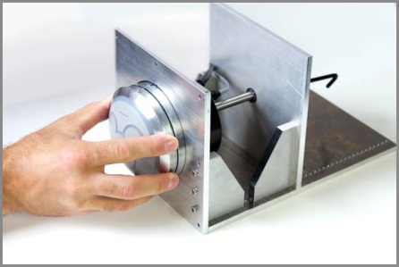

Figure 12.9 – Gently Push the xTP into the Stanchion

1. Turn the screw until the xTP is flush against the stanchion wall.

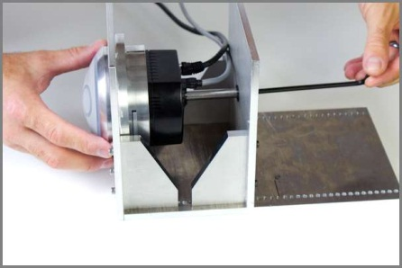

Figure 12.10 – xTP Flush Against Stanchion Wall

1. Continue to turn the screw until it feels snug.

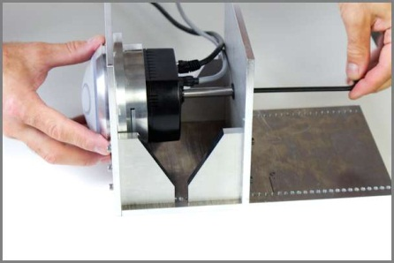

Figure 12.11 – Turning Screw Until it Feels Snug

1. The installation is complete.

**DAP Swap Out Procedure:**

This procedure requires a 3mm hex screwdriver.

To remove the DAP:

1. Unscrew the hatch.

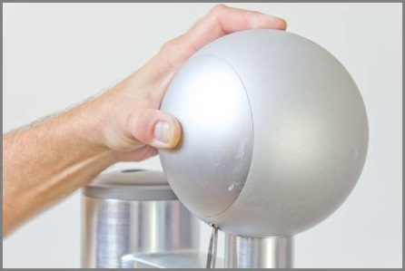

Figure 12.12 – Unscrewing the Hatch

1. Gently remove the hatch.

|  |  |
| --- | --- |
| S:\projects\Disney\Scooter\Photos and Video\2012-08-21 FOS Swap Out Procedure\JPG\Thumbnails for Manual\DAP stanchion-1\IMG_3877.jpg |  |

Figure 12.13 – Removing the Hatch

1. In the order given, unplug the Ethernet, USB, and power lead from the ports at the back.

|  |  |
| --- | --- |
| S:\projects\Disney\Scooter\Photos and Video\2012-08-21 FOS Swap Out Procedure\JPG\Thumbnails for Manual\DAP stanchion-1\IMG_3866.jpg | S:\projects\Disney\Scooter\Photos and Video\2012-08-21 FOS Swap Out Procedure\JPG\Thumbnails for Manual\DAP stanchion-1\IMG_3867.jpg |

Figure 12.14 – Unplugging the Ethernet, USB, and Power Lead

1. Loosen the screws that hold the xTPE in place and remove it.

|  |  |
| --- | --- |
| S:\projects\Disney\Scooter\Photos and Video\2012-08-21 FOS Swap Out Procedure\JPG\Thumbnails for Manual\DAP stanchion-1\IMG_3862.jpg | S:\projects\Disney\Scooter\Photos and Video\2012-08-21 FOS Swap Out Procedure\JPG\Thumbnails for Manual\DAP stanchion-1\IMG_3863.jpg |

Figure 12.15 – Unscrewing and Removing the xTPE

1. Loosen the screws that hold the retention bar in place.

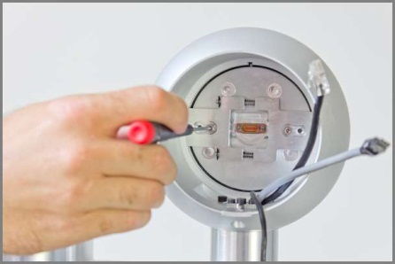

Figure 12.16 – Unscrewing the Retention Bar

1. Gently squeeze the retention bar from the grooves that hold it in place and remove it.

|  |  |
| --- | --- |
| S:\projects\Disney\Scooter\Photos and Video\2012-08-21 FOS Swap Out Procedure\JPG\Thumbnails for Manual\DAP stanchion-1\IMG_3840.jpg | S:\projects\Disney\Scooter\Photos and Video\2012-08-21 FOS Swap Out Procedure\JPG\Thumbnails for Manual\DAP stanchion-1\IMG_3842.jpg |

Figure 12.17 – Removing the Retention Bar

1. Hold the subassembly inside the stanchion and press the xTPX (Dome) lens from the font. Gently remove the xTPX (Dome) subassembly and leave the Ethernet, power lead, and USB cables hanging out the front for easy access.

|  |  |
| --- | --- |
| S:\projects\Disney\Scooter\Photos and Video\2012-08-21 FOS Swap Out Procedure\JPG\Thumbnails for Manual\DAP stanchion-1\IMG_3829.jpg | S:\projects\Disney\Scooter\Photos and Video\2012-08-21 FOS Swap Out Procedure\JPG\Thumbnails for Manual\DAP stanchion-1\IMG_3830.jpg |

Figure 12.18 – Removing the xTPX (Dome) Subassembly

To replace the DAP:

This procedure requires a 3mm hex screwdriver.

1. Ensure that the rubber edge of the xTPX (Dome) subassembly is lubricated with Molykote 55.

|  |  |
| --- | --- |
| S:\projects\Disney\Scooter\Photos and Video\2012-08-21 FOS Swap Out Procedure\JPG\Thumbnails for Manual\DAP stanchion-1\IMG_3821.jpg | S:\projects\Disney\Scooter\Photos and Video\2012-08-21 FOS Swap Out Procedure\JPG\Thumbnails for Manual\DAP stanchion-1\IMG_3822.jpg |

Figure 12.19 – Lubricating the xTPX

1. Orient the Trim Ring pin to the groove (12 o’clock).

|  |  |
| --- | --- |
| S:\projects\Disney\Scooter\Photos and Video\2012-08-21 FOS Swap Out Procedure\JPG\Thumbnails for Manual\DAP stanchion-1\IMG_3826.jpg | S:\projects\Disney\Scooter\Photos and Video\2012-08-21 FOS Swap Out Procedure\JPG\Thumbnails for Manual\DAP stanchion-1\IMG_3827.jpg |

Figure 12.20 – Orienting the Trim Ring Pin

1. Using the Trim Ring pin for orientation, slide the xTPX (Dome) subassembly in place.

|  |  |
| --- | --- |
| S:\projects\Disney\Scooter\Photos and Video\2012-08-21 FOS Swap Out Procedure\JPG\Thumbnails for Manual\DAP stanchion-1\IMG_3829.jpg | S:\projects\Disney\Scooter\Photos and Video\2012-08-21 FOS Swap Out Procedure\JPG\Thumbnails for Manual\DAP stanchion-1\IMG_3830.jpg |

Figure 12.21 – Using the Trim Ring Pin for Orientation

1. Gently press the xTPX (Dome) subassembly until it is firmly in place.

|  |  |
| --- | --- |
| S:\projects\Disney\Scooter\Photos and Video\2012-08-21 FOS Swap Out Procedure\JPG\Thumbnails for Manual\DAP stanchion-1\IMG_3837.jpg | S:\projects\Disney\Scooter\Photos and Video\2012-08-21 FOS Swap Out Procedure\JPG\Thumbnails for Manual\DAP stanchion-1\IMG_3836.jpg |

Figure 12.22 – Placing the xTPX (Dome) Subassembly in Place

1. Gently squeeze the retention bar so it fits into the groove.

|  |  |
| --- | --- |
| S:\projects\Disney\Scooter\Photos and Video\2012-08-21 FOS Swap Out Procedure\JPG\Thumbnails for Manual\DAP stanchion-1\IMG_3840.jpg | S:\projects\Disney\Scooter\Photos and Video\2012-08-21 FOS Swap Out Procedure\JPG\Thumbnails for Manual\DAP stanchion-1\IMG_3842.jpg |

Figure 12.23 – Placing the Retention Bar in Place

1. Note that the retention bar needs to be properly positioned. In the image on the left the bar is not properly aligned. It is properly aligned in the image on the right.

|  |  |
| --- | --- |
| S:\projects\Disney\Scooter\Photos and Video\2012-08-21 FOS Swap Out Procedure\JPG\Thumbnails for Manual\DAP stanchion-1\IMG_3852.jpg | S:\projects\Disney\Scooter\Photos and Video\2012-08-21 FOS Swap Out Procedure\JPG\Thumbnails for Manual\DAP stanchion-1\IMG_3853.jpg |

Figure 12.24 – Properly Aligning the Retention Bar

1. Gently tighten the screws until the retention bar is firmly in place.



Figure 12.25 – Screwing the Retention Bar in Place

1. Before placing the xTPE in position, note the connector needs to be properly aligned.

|  |  |
| --- | --- |
| S:\projects\Disney\Scooter\Photos and Video\2012-08-21 FOS Swap Out Procedure\JPG\Thumbnails for Manual\DAP stanchion-1\IMG_3857.jpg | S:\projects\Disney\Scooter\Photos and Video\2012-08-21 FOS Swap Out Procedure\JPG\Thumbnails for Manual\DAP stanchion-1\IMG_3858.jpg |

Figure 12.26 – Placement of Connector

1. Gently tighten the screws until it is firmly in place.

|  |  |
| --- | --- |
| S:\projects\Disney\Scooter\Photos and Video\2012-08-21 FOS Swap Out Procedure\JPG\Thumbnails for Manual\DAP stanchion-1\IMG_3862.jpg | S:\projects\Disney\Scooter\Photos and Video\2012-08-21 FOS Swap Out Procedure\JPG\Thumbnails for Manual\DAP stanchion-1\IMG_3863.jpg |

Figure 12.27 – Screwing the xTPE in Place

1. In the order given, plug in the Ethernet, USB, and power lead into the ports at the back.

|  |  |
| --- | --- |
| S:\projects\Disney\Scooter\Photos and Video\2012-08-21 FOS Swap Out Procedure\JPG\Thumbnails for Manual\DAP stanchion-1\IMG_3866.jpg | S:\projects\Disney\Scooter\Photos and Video\2012-08-21 FOS Swap Out Procedure\JPG\Thumbnails for Manual\DAP stanchion-1\IMG_3867.jpg |

Figure 12.28 – Plugging in the Ethernet, USB, and Power Lead

1. Note that the arrow on the power lead is facing down when plugged in.

|  |  |
| --- | --- |
| S:\projects\Disney\Scooter\Photos and Video\2012-08-21 FOS Swap Out Procedure\JPG\Thumbnails for Manual\DAP stanchion-1\IMG_3870-2.jpg | S:\projects\Disney\Scooter\Photos and Video\2012-08-21 FOS Swap Out Procedure\JPG\Thumbnails for Manual\DAP stanchion-1\IMG_3873-2.jpg |

Figure 12.29 – Arrow on Power Lead

1. Note the position of the wires and the placement hole before proceeding.

|  |  |
| --- | --- |
| S:\projects\Disney\Scooter\Photos and Video\2012-08-21 FOS Swap Out Procedure\JPG\Thumbnails for Manual\DAP stanchion-1\IMG_3875.jpg | S:\projects\Disney\Scooter\Photos and Video\2012-08-21 FOS Swap Out Procedure\JPG\Thumbnails for Manual\DAP stanchion-1\IMG_3876.jpg |

Figure 12.30 – Wire Position and Placement Hole

1. Orient the hatch pin to the groove in the DAP.

|  |  |
| --- | --- |
| S:\projects\Disney\Scooter\Photos and Video\2012-08-21 FOS Swap Out Procedure\JPG\Thumbnails for Manual\DAP stanchion-1\IMG_3877.jpg | S:\projects\Disney\Scooter\Photos and Video\2012-08-21 FOS Swap Out Procedure\JPG\Thumbnails for Manual\DAP stanchion-1\IMG_3879.jpg |

Figure 12.31 – Orienting the Hatch

1. Note the position of the spring and placement hole.

|  |  |
| --- | --- |
| S:\projects\Disney\Scooter\Photos and Video\2012-08-21 FOS Swap Out Procedure\JPG\Thumbnails for Manual\DAP stanchion-1\IMG_3880.jpg | S:\projects\Disney\Scooter\Photos and Video\2012-08-21 FOS Swap Out Procedure\JPG\Thumbnails for Manual\DAP stanchion-1\IMG_3881.jpg |

Figure 12.32 – Positioning the Hatch

1. Before using the hex key, start to place the screw in position with your hand.

|  |  |
| --- | --- |
| S:\projects\Disney\Scooter\Photos and Video\2012-08-21 FOS Swap Out Procedure\JPG\Thumbnails for Manual\DAP stanchion-1\IMG_3886.jpg | S:\projects\Disney\Scooter\Photos and Video\2012-08-21 FOS Swap Out Procedure\JPG\Thumbnails for Manual\DAP stanchion-1\IMG_3887.jpg |

Figure 12.33 – Position of Placement Screw

1. Gently screw the subassembly into place.



Figure 12.34 – Screwing the Subassembly into place

1. The installation is complete.

|  |  |
| --- | --- |
| S:\projects\Disney\Scooter\Photos and Video\2012-08-21 FOS Swap Out Procedure\JPG\Thumbnails for Manual\DAP stanchion-1\IMG_3892.jpg | S:\projects\Disney\Scooter\Photos and Video\2012-08-21 FOS Swap Out Procedure\JPG\Thumbnails for Manual\DAP stanchion-1\IMG_3893.jpg |

Figure 12.35 – Installation is Complete

## Performing the xTP Association in xBRMS

After the xTP has been physically replaced and plugged in at the venue, it starts sending HELLO messages to xBRMS. Once an xBRMS receives the HELLO, it will acknowledge that reader as an unlinked reader available to use for replacements. To complete the device replacement process, the device must be assigned to the reader location of the former reader device.

The following steps describe the process for associating the xTP with the xBRC in xBRMS, once the device has been physically replaced in the field.

### Replacing an xTP in xBRMS

1. Open your internet browser and launch xBRMS service. Enter your credentials into the fields for **User name** and **Password**. Click **Login**.

**Tip**: For the fastest access to the **Replace Reader** page, create a desktop shortcut directly to this page from your browser.

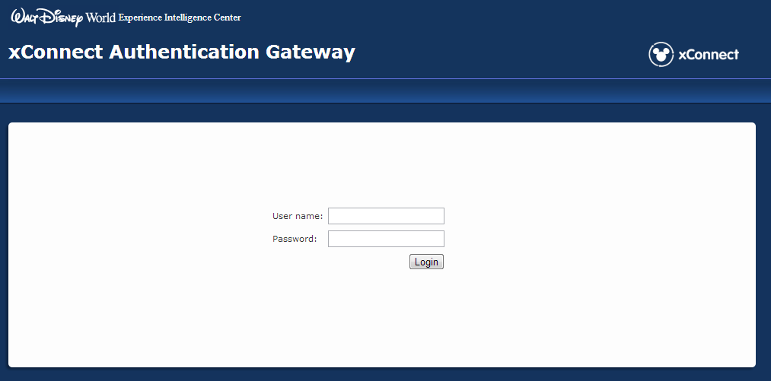

Figure 12.2.1 – xBRMS login page

1. The **XBand Reader Management System** landing page appears.

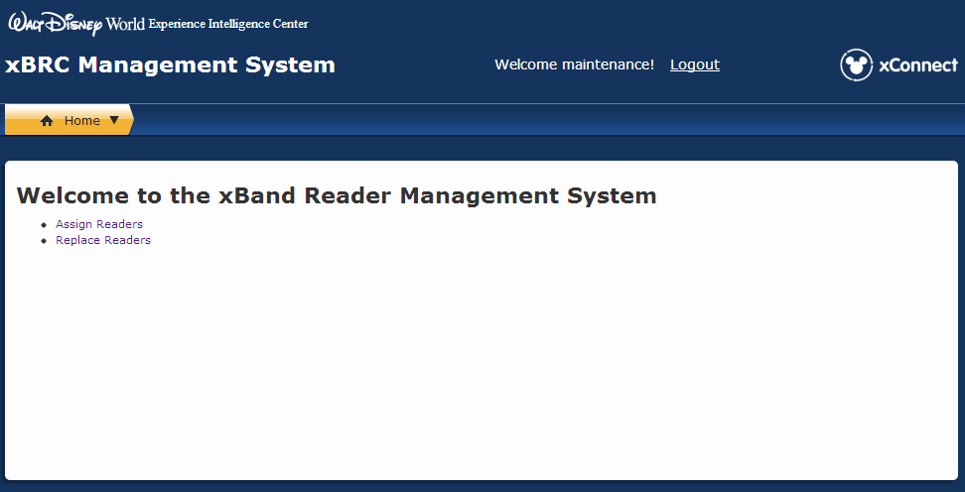

Figure 12.2.2 – xBRMS landing page

1. Under **Choose** On the **xBR Management System Home** page, click the link for **Assign Reader**.

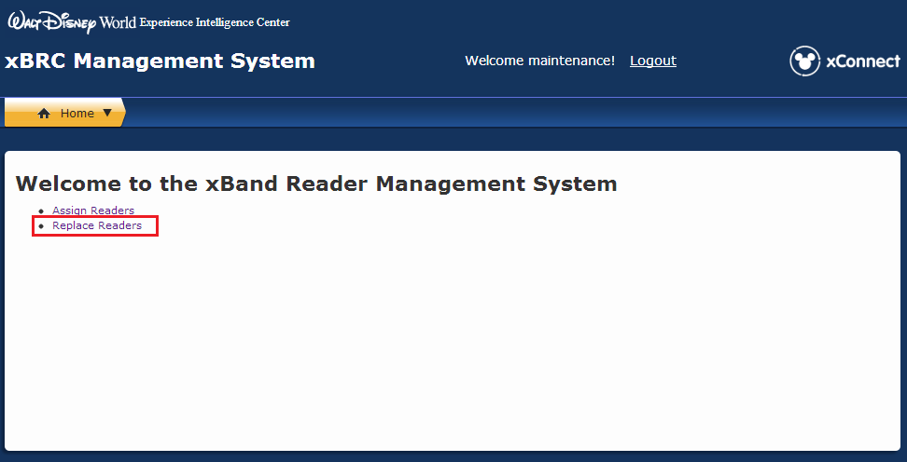

Figure 12.2.3 – xBRMS Home Page with Replace Reader link

1. The **Replace Reader** screen appears.

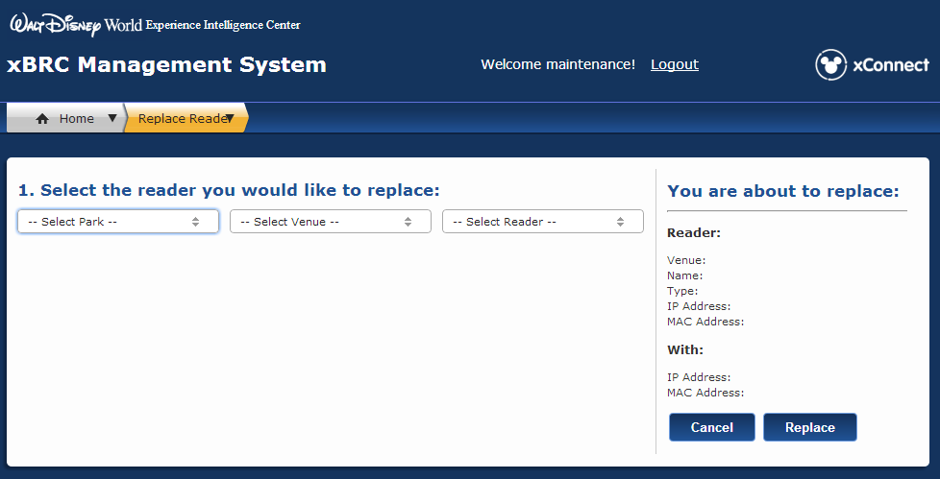

Figure 12.2.4 – Replace Reader screen

1. On the **Replace Reader** screen, begin step **1.** **Select the reader you would like to replace**, by expanding the **Select Park** drop-down list to show all parks with readers that display a yellow or red Health status in xBRMS.

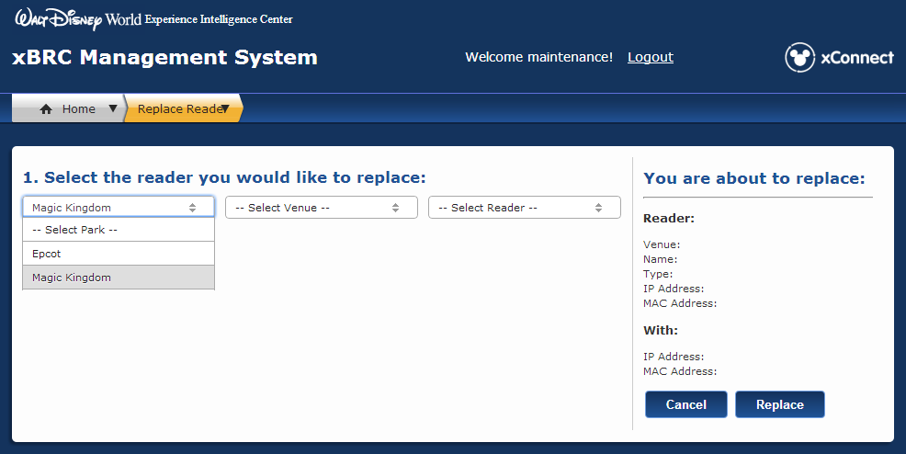

Figure 12.2.5 – List of parks

1. On the **Replace Reader** screen, choose the correct park for the reader that needs to be replaced. For this example, we are using **Magic Kingdom**.

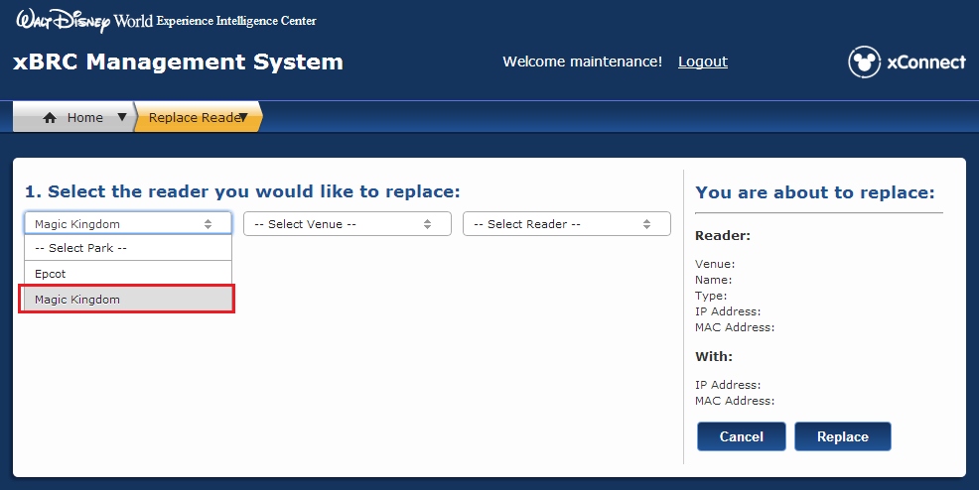

Figure 12.2.6 – Select the park

1. On the **Replace Reader** screen, expand the drop-down list for **Select Venue**,todisplay a list of all available venues for the park.

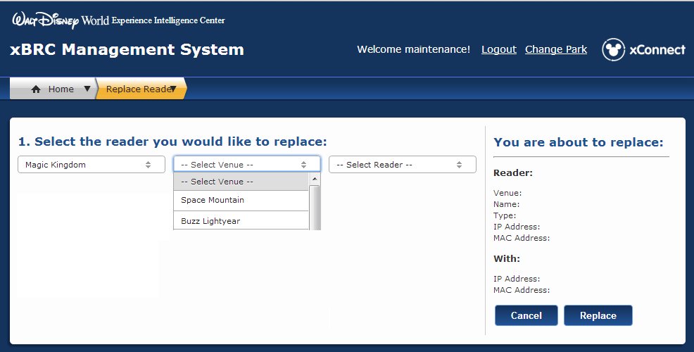

Figure 12.2.7 – List of venues for this park

1. Choose the venue within this park for the reader that needs to be replaced. For this example, we are using **Buzz Lightyear**.

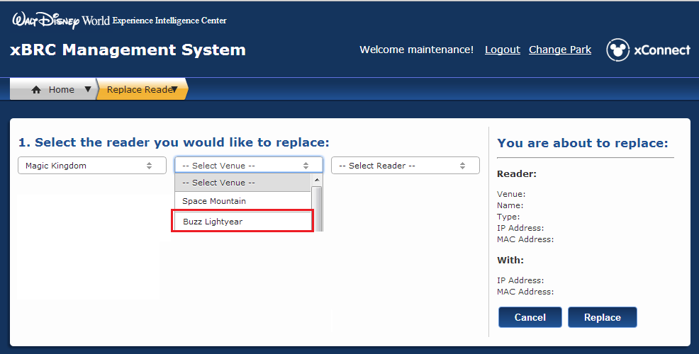

Figure 12.2.8 – Select the venue for this park

1. On the **Replace Reader** screen, expand the drop-down list for **Select Reader** to display a list of all readers of the same type for the park and venue you’ve selected. For example, when replacing a FastPass+ reader, only FastPass+ replacement reader candidates will appear in the list.

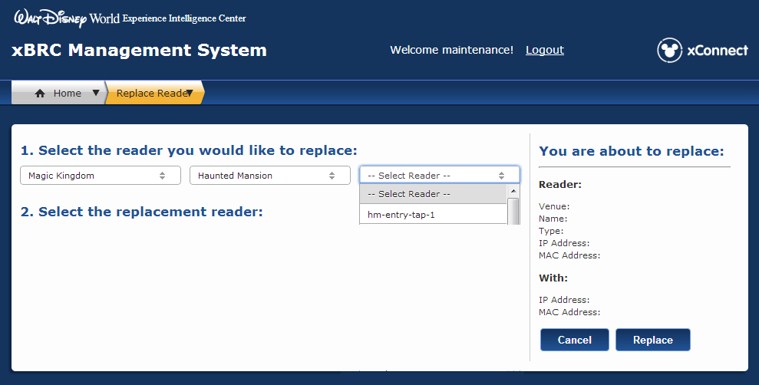

Figure 12.2.9 – List of readers for this venue

1. Choose the reader to replace for this park and venue. For this example, we are using **hm-entry-tap-1**.

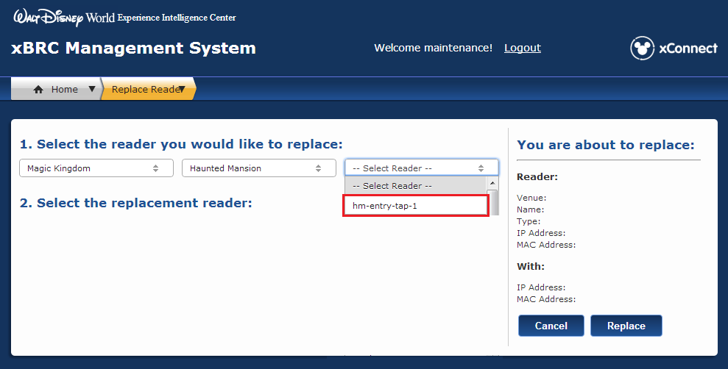

Figure 12.2.10 – Select the reader to be replaced

1. Once you have selected the reader to be replaced, a list of all replacement candidates for this type of reader appears under step **2**. **Select the replacement reader**.

**Important**: If you don’t see the reader you’re looking for in the list, it may first need to be assigned to the correct xBRC before it can be managed correctly in the Replace Reader process. If you don’t find the reader in the list, click the **Home** tab and click the **Assign Readers** link, then follow the steps in the next section.

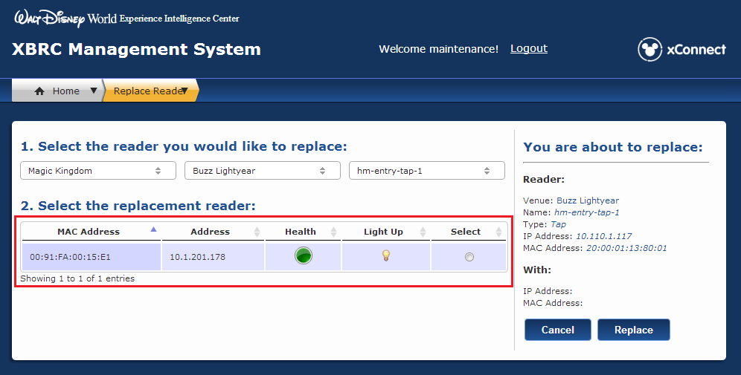

Figure 12.2.11 – Replacement reader candidate list

1. Select the reader to use for this replacement. For this example, we are using the unlinked reader with the MAC Address 00:91:FA:00:15:E1.

**Tip**: For xTP readers (for FastPass+, for example), click the light bulb icon to “light up” the reader face plate. When clicked, the xTP will display a yellow light sequence for 60 seconds. This validates the correct replacement device before completing the replacement process. Once the light sequence begins, the Command Center Technician can resume the replacement process. You don’t need to wait until the light sequence completes—the lights will turn off automatically.

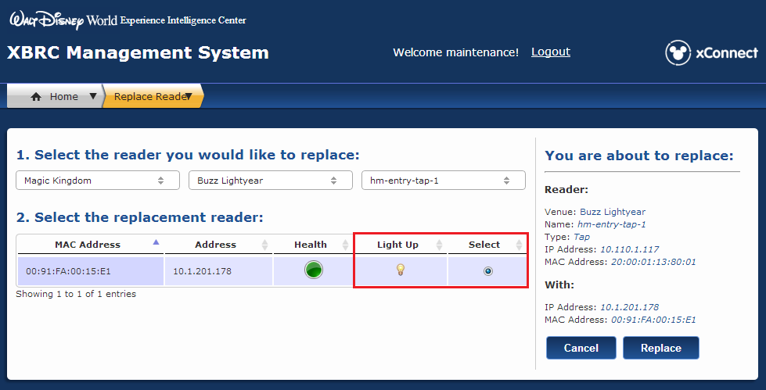

Figure 12.2.12 – Replacement readers list with Light Up icon

**Important**: The **Health** column provides information about the performance of all replacement reader candidates, displaying green, yellow or red light icons. The health status for a newly installed reader should always be green. If it is red, verify that all physical connections are secure and cycle power. If after two minutes the status condition is still red, try installing another device or escalate the issue.

1. Verify the change by validating the information in the **You are about to replace:** section.

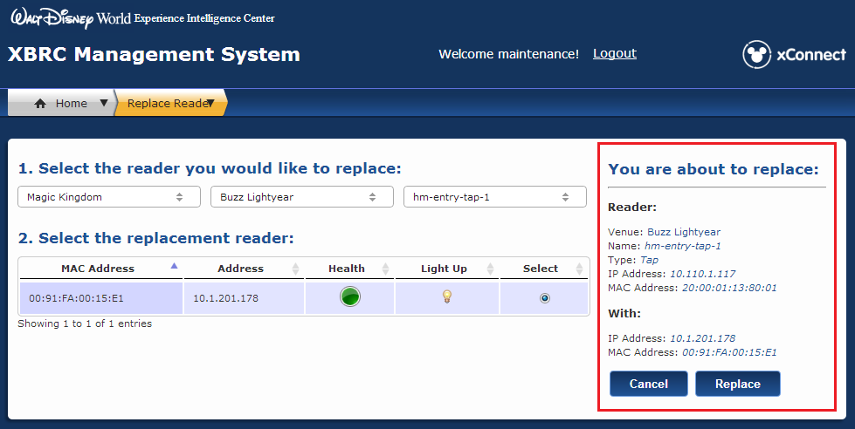

Figure 12.2.13 – Replace Reader confirmation

1. Once you have confirmed the replacement reader, click **Replace**.

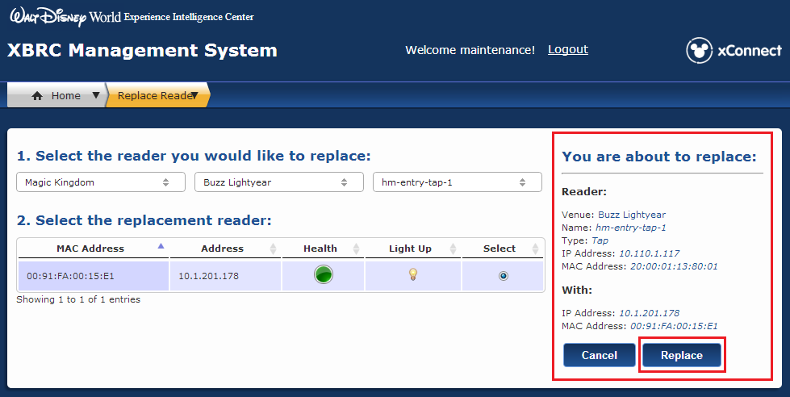

Figure 12.2.14 – Click Replace to complete the replacement

1. A **Confirm Replace Operation** dialog appears. Click **Yes** to proceed with the replacement.

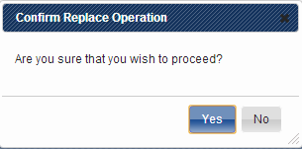

Figure 12.2.15 – Confirm Replace Operation dialog

1. The **Success** dialog appears, confirming the successful replacement of the reader. Click **OK**. The old reader was deleted from the system and the new reader took its place, inheriting the necessary settings and attributes from the old reader.

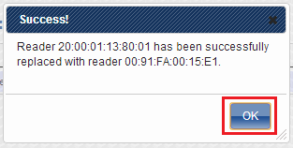

Figure 12.2.16 – Success dialog

## Identifying and assigning unassigned readers

Once a reader has been replaced in the field, the Command Center Technician must complete the process to replace a reader in xBRC, which links the new reader to the correct location. If the newly installed reader doesn’t appear in the Replace Readers list, it may not be assigned to an xBRC.

This section provides steps to:

* Identify unassigned readers
* Assign them to the correct xBRC
* Complete the steps in xBRMS to replace the reader at an attraction

### Assigning a reader to the correct xBRC

1. To access the **Assign Readers** page, click the **Home** tab in xBRMS from anywhere in the application.

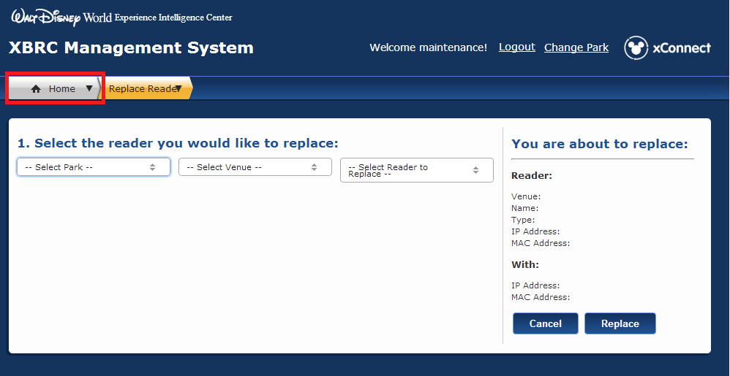

Figure 12.3.1 – xBRMS Home page tab

1. The xBRMS home page appears, showing all links that are available.



Figure 12.3.2 – xBRMS landing page

1. Once you have returned to the xBRMS Home page, click the **Assign Readers** link.

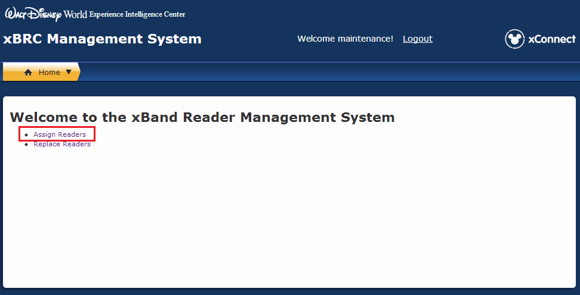

Figure 12.3.3 – xBRMS Assign Readers link

**Tip**: For the fastest access to the **Assign Readers** page, create a desktop shortcut directly to this page from your browser.

1. The **Found Readers** screen appears that shows a list of all unassigned readers and a drop-down list showing xBRCs for each park.

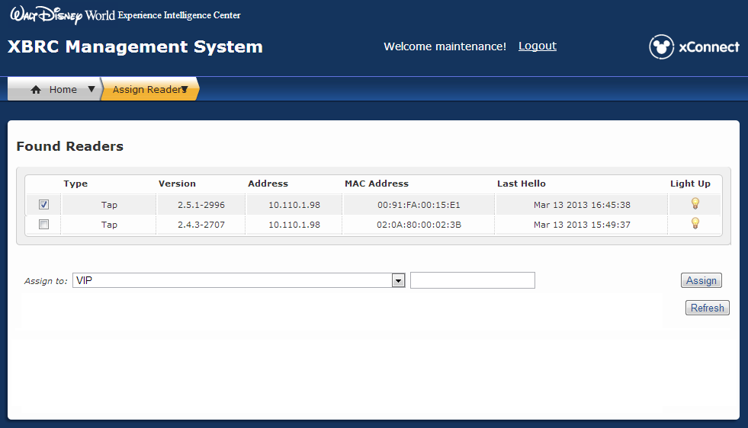

Figure 12.3.4 – xBRMS Found Readers screen

1. Find the MAC Address for the new reader, and check the box to select it in the **Found Readers** list. For this example, we are looking for an xTP (a tap reader) with the MAC Address 00:91:FA:00:15:E1.

**Note:** All readers are assigned a unique MAC Address, which is affixed to the device on a white sticker. If you don’t already have the MAC Address for the new reader that was installed, ask the Field Technician to provide it.

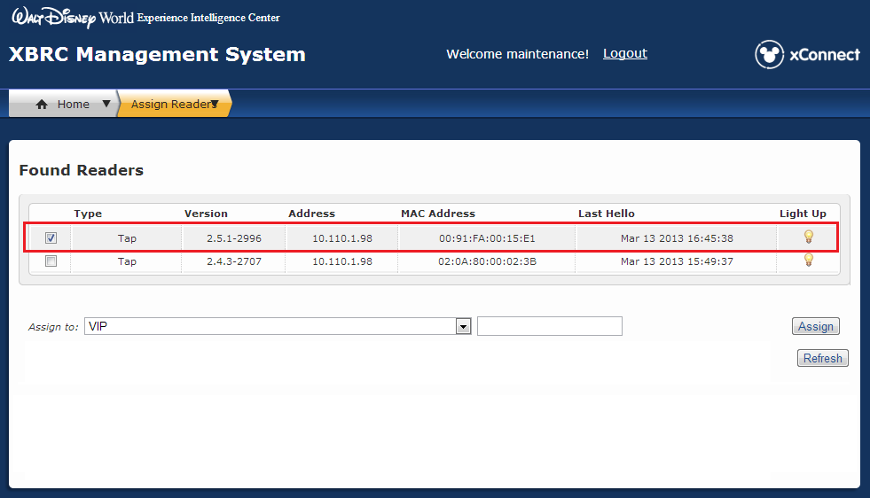

Figure 12.3.5 – xBRMS Found Readers list

1. For xTPs (tap readers) click the light bulb icon in the **Light Up** column. This will cause the xTP to flash its light, confirming that you are assigning the correct reader.

**Tip**: When **Light Up** is selected, the xTP face plate will display a yellow light sequence for 60 seconds. This validates that you are linking the correct replacement device before completing the replacement process. Once the light sequence begins, the Command Center Technician can resume the replacement process. You don’t need to wait until the light sequence completes—the lights will turn off automatically.

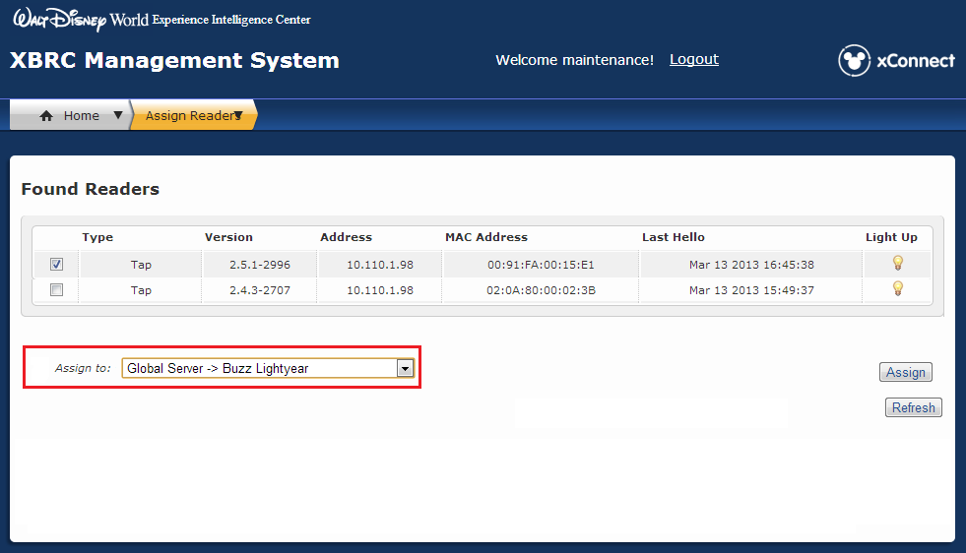

Figure 12.3.6 – Light up xTP

1. With the reader selected in the list, expand the **Assign To** drop-down list and choose the xBRC that you want to assign this reader to. The xBRC is usually named after the attraction.

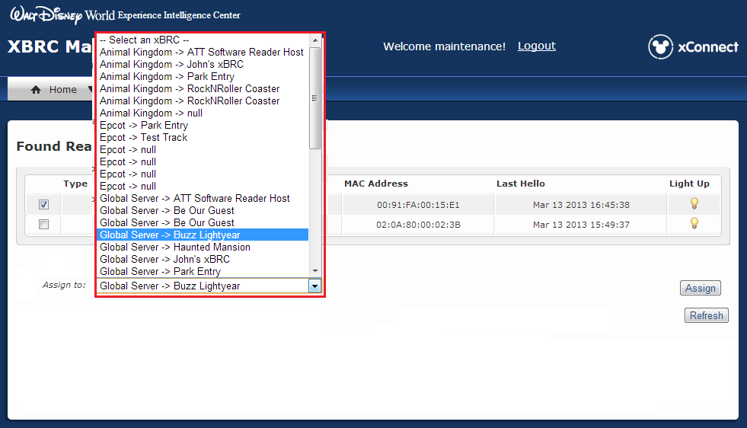

Figure 12.3.7 – List of all xBRCs

1. Select the xBRC that you want to assign the selected reader to.

 Figure 12.3.8 – Select an xBRC

1. Click **Assign**. The reader is now assigned to the correct xBRC and will appear in the **Replace Reader** list for easy management.

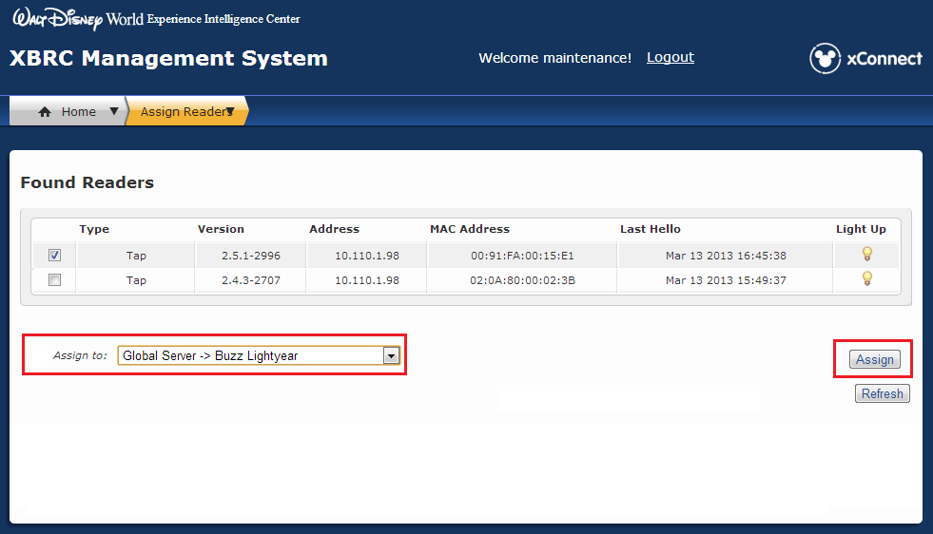

Figure 12.3.9 – Assign a reader to an xBRC

1. A **Success** message appears, confirming that the reader has been assigned to the xBRC.

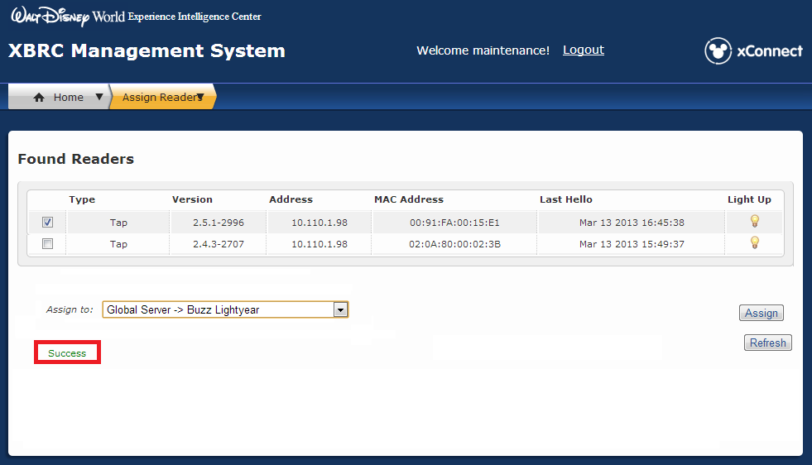

Figure 12.3.10 – Success confirmation

1. Now that you have assigned the reader to the right xBRC, you can now replace the reader with a new one. Complete the steps in Section 12.2.1 “Replacing an xTP in xBRMS” to complete the reader replacement process.

## If the reader does not show in xBRMS

If these steps do not correct the problem, escalate the issue by calling x8665 within Disney or 1-866-5DISNEY if not on a Disney land line. Request to have a ticket opened to the app-flwdw-ngexcon team as a priority 3.

## Testing the xTP

The following table lists the tests to run after the replacement and the response showing the xTP is functioning correctly.

|  |  |
| --- | --- |
| **Testing the xTP for main entry** | **Expected Response** |
| Tap with MagicBand/FastPass + test card that has an entry entitlement | The following sequences indicate a tap with a valid entry entitlement:  Park Entry (DAP) Process:   1. “Tap” sound is played in sequence with light ring on the xTP flashing green. 2. Light flashes until system indicates the band or card belongs to a child or adult. 3. If the response comes back as an adult:    1. Bio reader light flashes white 3 times in sequence with “bio scan prompt” sound.    2. Service personnel begins bio reader scan.    3. Upon completed scan, bio reader light goes through spinning animation while fingerprint is checked.    4. “Success” sound is played and all lights (Mickey, light ring, and bio ring) turn green for 1.5 seconds. 4. If the response comes back as child, the “success” sound is played and Mickey light turns green for 1.5 seconds. |
| Touch xTP with MagicBand (or test card) that doesn’t have FastPass+ entitlement | “Tap” sound is played and light ring on the xTP blinks green for short period.  “Exception” sound is played while light ring and bio ring flash blue. |
| **Testing the xTP for FastPass+:** | **Expected Response** |
| Touch xTP with MagicBand (or test card) that has a FastPass+ entitlement. | 1. “Touch” sound is played in sequence with light ring on the xTP flashing green. 2. “Success” sound is played and all lights (Mickey and light ring,) turn green for about 1.5 seconds. |
| Touch xTP with MagicBand (or card) that doesn’t have FastPass+ entitlement. | “Touch” sound is played and light ring on the xTP blinks green for a short period.  “Exception” sound is played while light ring flashes blue. |
|  | Test Complete |

## Troubleshooting problems with the xTP

The following table lists the problems that you might experience with the xTP and how you can resolve or escalate the problem.

|  |  |
| --- | --- |
| **Problem with the xTP** | **How to resolve or escalate this problem** |
| The LEDs in the xTP are not working | **How to identify**: When the xTP is tapped, the tap sound plays but the light ring on the xTP fails to flash green  **How to resolve**: Swap out the xTP following the instruction in section 12.1  **How to escalate**: N/A |
| The audio in the xTP is not working | **How to identify**: When the xTP is tapped, light ring flashes green but the tap sound fails to play  **How to resolve**: Swap out the xTP following the instruction in section 12.1  **How to escalate**: N/A |
| Both the LEDs and audio in the xTP are not working | **How to identify**: When the xTP is tapped, light ring on the xTP fails to flash green and the tap sound fails to play.  **How to resolve**: Check the power supplies and switch to ensure xTP has power and network connection. Troubleshoot as necessary. To swap out the xTP follow the instructions in Section 12.1  **How to escalate**: N/A |
| The xTP is taking too long to read MagicBands | **How to identify**: It takes over 15 seconds for the xTP to respond to the tap.  **How to resolve**: N/A  **How to escalate**: This could have several causes (slow network and slow response from a software application being the most likely). Contact the Control Center for appropriate escalation. |
| The xTP loses power | **How to identify**: The xTP does not respond when tapped and fails to respond when power is applied  **How to resolve**: Check the power supplies and replace as necessary. Swap out the xTP following the instructions in Section 12.1  **How to escalate**: N/A |

# Obsolete Equipment

The timeframe for the release of a new version of the xTP is TBD.